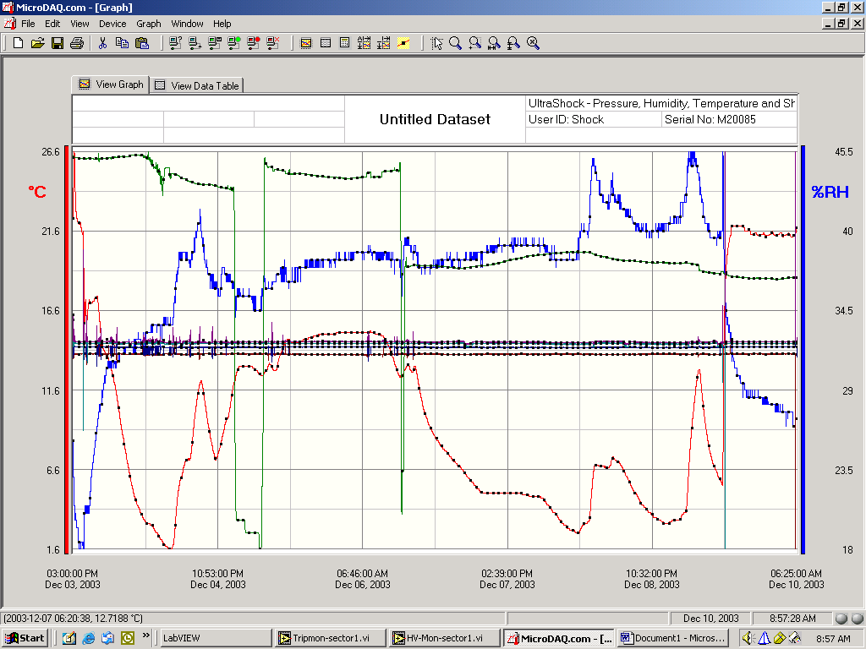

temperature

humidity

absolute pressure

shocks: vector sum X-axis Y-axis Z-axis

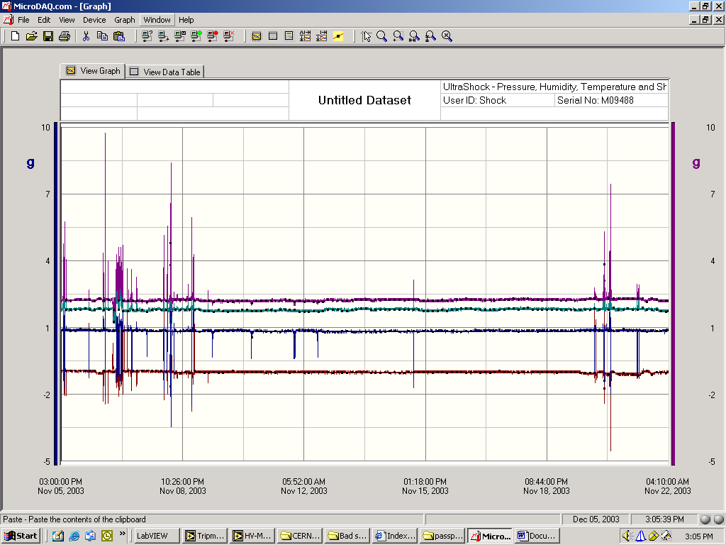
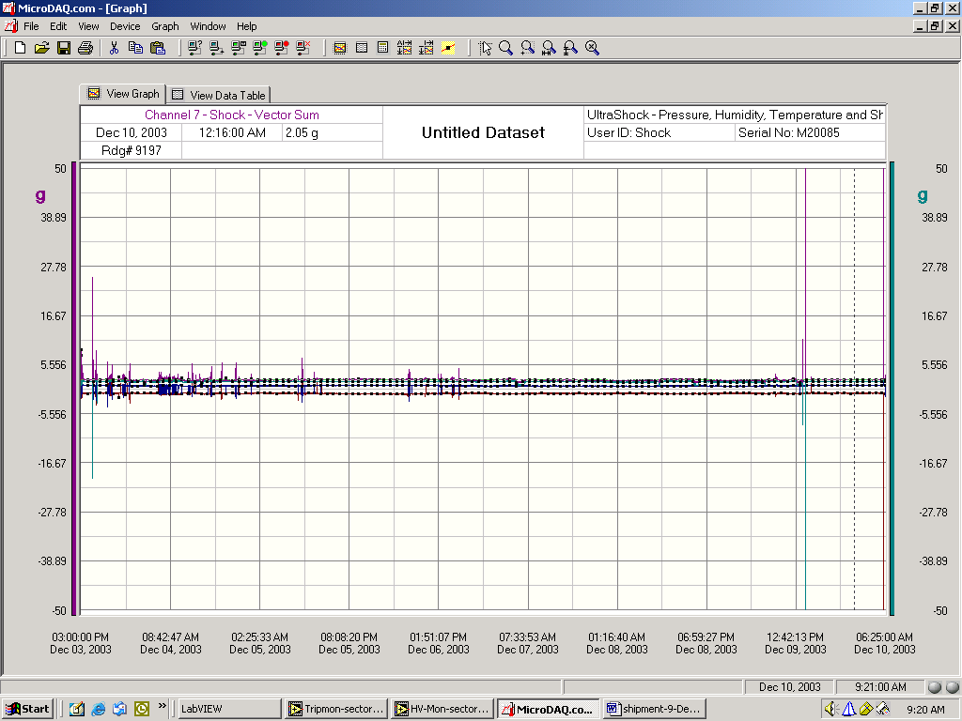

shocks: vector sum X-axis Y-axis Z-axis

